Exercise 1: Hello with Date Time

I expect that the values would be:

* 1
* 2
* 3
* 1

Result:

In debugger, when expanding the variable a, it will loop values in variable a,b,c as they reference each other.

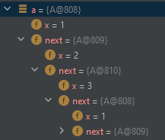

Exercise 2: Sketching Object Graphs

Exercise 3: Complete the Inefficient Implementations of LinkedList and ArrayList.

Contains method for LinkedList

Contains method for ArrayList

Exercise 4: Minimal rewrite of LinkedList and ArrayList to improve efficiency

Append function for EfficientLinkedList

Append function for EfficientArrayList

Code extension of ListExample

Output using an extension of ListExample

|  |  |  |  |
| --- | --- | --- | --- |
| LinkedList | EfficientLinkedList | ArrayList | EfficientArrayList |
|  |  |  |  |

Exercise 5: Performance Tests

Code used to test (slightly modified so I don’t have to change the code multiple times for a new number of elements)

The average of EfficienctArrayList is constant while EfficientLinkedList for any case of append is constant